For Immediate Release Contact: [Contact Name]
Phone: [Phone Number]
Email: [Email]

[Affiliate Name] to Participate in First-Ever Giving Day Event
Local nonprofit to join Family Promise National’s Giving Day

[CITY, STATE], OCTOBER 25 – This October, [Affiliate Name] will participate in Family Promise’s first Giving Day, a one-day online event to raise awareness of Family Promise and the crisis of family homelessness in the U.S. The nonprofit is one of 80 Family Promise Affiliates nationwide participating in a campaign to raise $1 million for families experiencing homelessness.

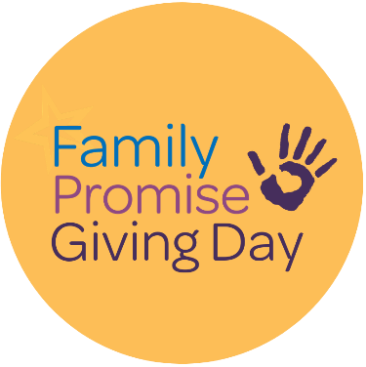
“[Quote from Affiliate Director],” says [title] [name]. “[Additional quote].”
[Insert info on local in person event if applicable]
[Insert info on local government proclamations or actions]
For information on Family Promise Giving Day and [Affiliate name], please reach out to [name].
_________________________________________________________________________________________________________________________
Family Promise envisions a nation in which every family has a home, a livelihood, and the chance to build a better future. What began as a local initiative in Summit, NJ, has become a national movement that involves 200,000 volunteers and serves more than 90,000 family members each year. Family Promise will change the future for 1 million children by 2030. Let’s start on October 25!
For more information about Family Promise Giving Day, please visit www.fpgives.org.

