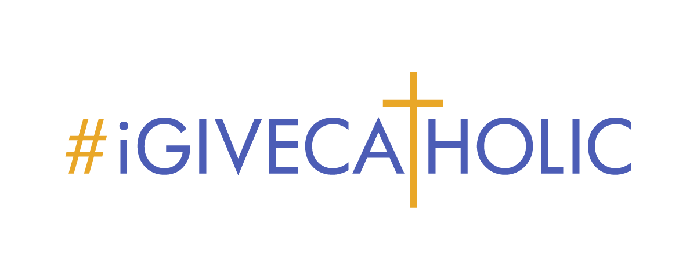

***DEMYSTIFYING THE MYTHS***

***Answers to Common Roadblocks that May Hinder Organization Participation***

**THE FEES ARE TOO HIGH!**

The most widely expressed complaint we hear. A separate resource document addressing concerns and providing talking points can be found on the Partner Resource Portal.

**THIS WILL BE TOO MUCH WORK!**

Plug and play resources are offered for everything - No Guesswork is involved!

* “Just One Thing” email series - one task per week starting after Labor Day
* All marketing materials provided
* Best practice examples specific to parishes, schools and ministries provided
* Social media templates provided
* *“Holy Plagiarism” is not only supported, but encouraged!*

**WE DON’T HAVE ANY EXTRA TIME FOR THIS!**

Just follow the proven game plan provided. Weekly each Monday after Labor Day - the Giving Day in November!

* + Commitment is no more than one to two hours per week
  + One task per week to accomplish
  + Attend three one-hour informational webinars - two in August and one in November

**OUR STAFF IS TOO SMALL!**

One point person and a few committed volunteers will get the job done…divide and conquer!

* + One administrative person charged with oversight -- PLUS perhaps help in the following areas:
    - Profile page
    - Social media
    - Communications
    - On-site event (if an event will be held)
    - Thank you notes

**PASTOR CONCERNED ABOUT DONOR FATIGUE!**

#iGiveCatholic will not threaten weekly offertory – it will invite people who don’t sit in your pews or regularly contribute to make a special gift. For example:

* + A couple who was married in your church or received other sacraments there
  + Someone who is homebound and watches your masses online
  + Parishioners who moved away but still value their past time with your parish

**OUR DONORS DON’T WANT ANOTHER APPEAL!**

AKA “this will take away from other initiatives” – Bishop’s Appeal, Capital Campaign, Annual Fund, etc.

Or “we already participate in a giving day at another time of the year.”

* #GivingTuesday is the biggest day of philanthropy all year. **If we don’t ask, someone else will and they will get donations, but not us!**
* #iGiveCatholic is *the U.S. Catholic Church’s giving day*, **a unique and exciting celebration of our Catholicity.** Beyond additional donations, this campaign can inspire stronger connections with your Catholic community.
* **Your donors WANT to be a part of this!** They love to share their blessings in gratitude and feel the need to give. True Christian stewardship is very REAL!
* Platform features such as Support Areas **give donors an opportunity to show love for specific causes or groups that are near and dear to their hearts** (i.e. specific program of your ministry, a particular mass time community, a specific range of alumni classes, or a specific current grade or class in school, etc.)
* **Will NOT negatively impact other, existing appeals!** Post-giving day donor surveys consistently indicate that the majority of donors say this has no impact on their giving, 12% report they actually give MORE to existing campaigns, 7% give less, the rest indicate they don’t know.