Mrs. Jane Doe
123 Address
City, State ZIP

Dear Mrs. Doe,

The Catholic Community Foundation invites you to participate in this year’s #iGiveCatholic giving day. Held annually on #GivingTuesday, which is December 3rd this year, #iGiveCatholic is a 24-hour online campaign that provides Catholic donors with the opportunity to support the Catholic parishes, schools, and nonprofit ministries that are close to their heart.
As a service to our fund holders, you may designate distributions to participating organizations completing and returning the enclosed form. We have also included a list of all participating organizations in the Diocese of XX. We ask that grant distributions be allocated at a minimum of $100 each, per our usual policy. If you decide to make these designations through the usual software, please add #iGiveCatholic to the note field.
By giving through your donor advised fund (DAF), you will avoid any platform or credit card fees, allowing organizations to benefit from the full impact of your giving. Gifts through your DAF will be added to the leaderboards of your selected organizations, generating even more excitement and encouraging others to give!
I encourage you to visit diocese.igivecatholic.org to learn more about #iGiveCatholic and the individual organizations who are participating. Each has the opportunity to dedicate their campaign to a specific project or program and share related images or video on their unique page on the #iGiveCatholic platform. You can search for organizations by name, city or even specific Catholic cause (i.e. Homelessness and Housing, Marriage & Family, Vocations & Seminarians).
The deadline to receive your #iGiveCatholic allocations is Monday, December 9, but we encourage you to submit at your earliest convenience to add momentum to this wave of Catholic generosity.
If you have any questions, please contact me at 534.589.5557 or name@ccfdiocese.org.

With gratitude,

Name, Title

Please complete and return this form by mail to 2345 Mailing Address, City, State ZIP or scan and email to: name@ccfdiocese.org. All designations received by close of business on Monday, December 9, 2024 will be added to #iGiveCatholic campaign totals for each beneficiary organization. Checks will be distributed following the end of the giving day.

I’d like to participate in #iGiveCatholic by making the following distributions from my Donor Advised Fund.

Printed Name: ______________________________________

Signature: __________________________________________
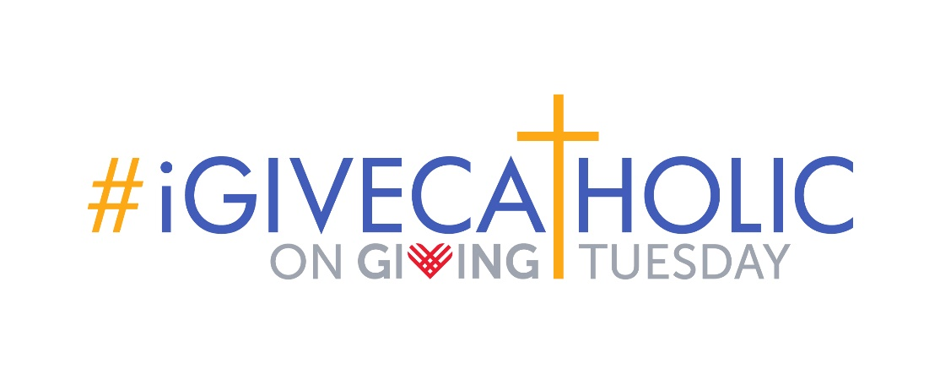

Grant Amount | Name of Participating Organization
$
$
$
$
$
$
$
$
$
$
$
$
$
$
$

#iGiveCatholic email to DAF holders
Schedule to send NO LATER than November 18, 2024.
Subject: Use your DAF to Pay for Donations through #iGiveCatholic!

The Catholic Community Foundation invites you to participate in this year’s #iGiveCatholic giving day. Held annually on #GivingTuesday, which is December 3rd this year, #iGiveCatholic is a 24-hour online campaign that provides Catholic donors with the opportunity to support the Catholic parishes, schools, and nonprofit ministries that are close to their heart.
As a service to our fund holders, you may designate distributions to participating organizations completing and returning the attached form. We have also attached a list of all participating organizations in the Diocese of XX. We ask that grant distributions be allocated at a minimum of $100 each, per our usual policy. If you decide to make these designations through the usual software, please add #iGiveCatholic to the note field.
By giving through your donor advised fund (DAF), you will avoid any platform or credit card fees, allowing organizations to benefit from the full impact of your giving. Gifts through your DAF will be added to the leaderboards of your selected organizations, generating even more excitement and encouraging others to give!
I encourage you to visit diocese.igivecatholic.org to learn more about #iGiveCatholic and the individual organizations who are participating. Each has the opportunity to dedicate their campaign to a specific project or program and share related images or video on their unique page on the #iGiveCatholic platform. You can search for organizations by name, city or even specific Catholic cause (i.e. Homelessness and Housing, Marriage & Family, Vocations & Seminarians).
The deadline to receive your #iGiveCatholic allocations is Monday, December 9, but we encourage you to submit at your earliest convenience to add momentum to this wave of Catholic generosity.
If you have any questions, please contact me at 534.589.5557 or name@ccfdiocese.org.

With gratitude,

Name, Title

