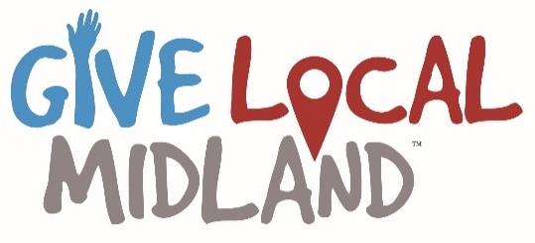
Mail-In Donation Form
Instructions: 1.) visit GiveLocalMidland.org to view participating organizations.
2.) Complete this form and then print it or vice versa
3.) Write one check for the total donation amount and make check payable to MACF.
4.) Mail completed donation form and check/cash postmarked by April 27 to MACF, 76 Ashman Circle, Midland, MI 48640
5.) Thank you!

Name:_____________________________________________________
First Last Spouse/Partner
Address:
City State Zip

Email: Phone Number:

Total Gift Amount: Check Number:
If you want to pay with a credit card, please visit GiveLocalMidland.org on May 5.
Questions? Contact 989-839-9661 or info@midlandfoundation.org

Organization or Fund Name  (If you want to make more than 15 donations, include them on a separate sheet of paper) | Donation Amount | Would you like your donation to be anonymous? (Y/N) | Are you a new donor to this organization?  (Y/N)
Total Donation Amount:
(Add lines 1 through 15)

